Project Name:DemoBlaze
Module:Login, Cart & Purchase
Testing Type: Manual Testing
Webpage URL: https://www.demoblaze.com/

● Scenario ID: 1a
Scenario: Open Website
Test Steps:
Open DemoBlaze website

Screenshots:
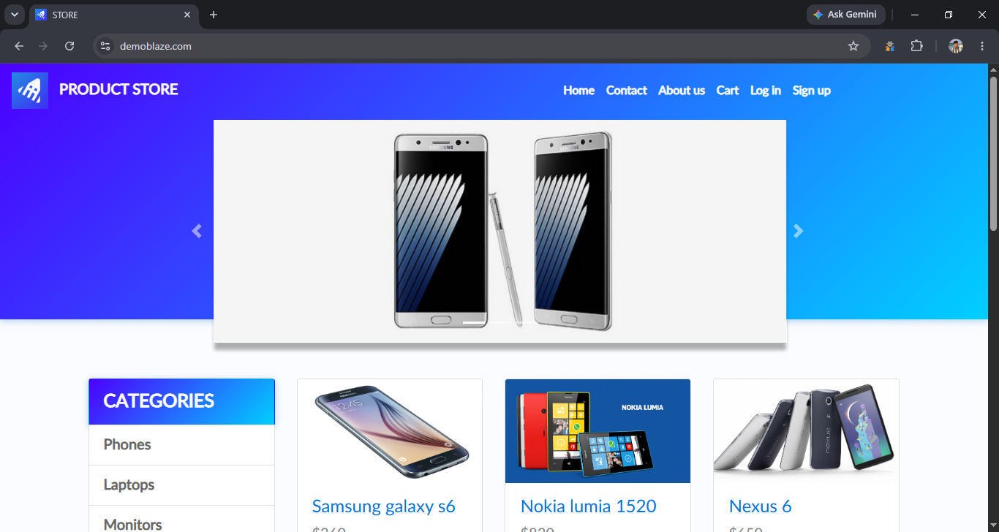

● Scenario ID: 1b
Scenario: Sign Up
Test Steps:
Click Sign Up → Enter username and password → Submit

Screenshots:
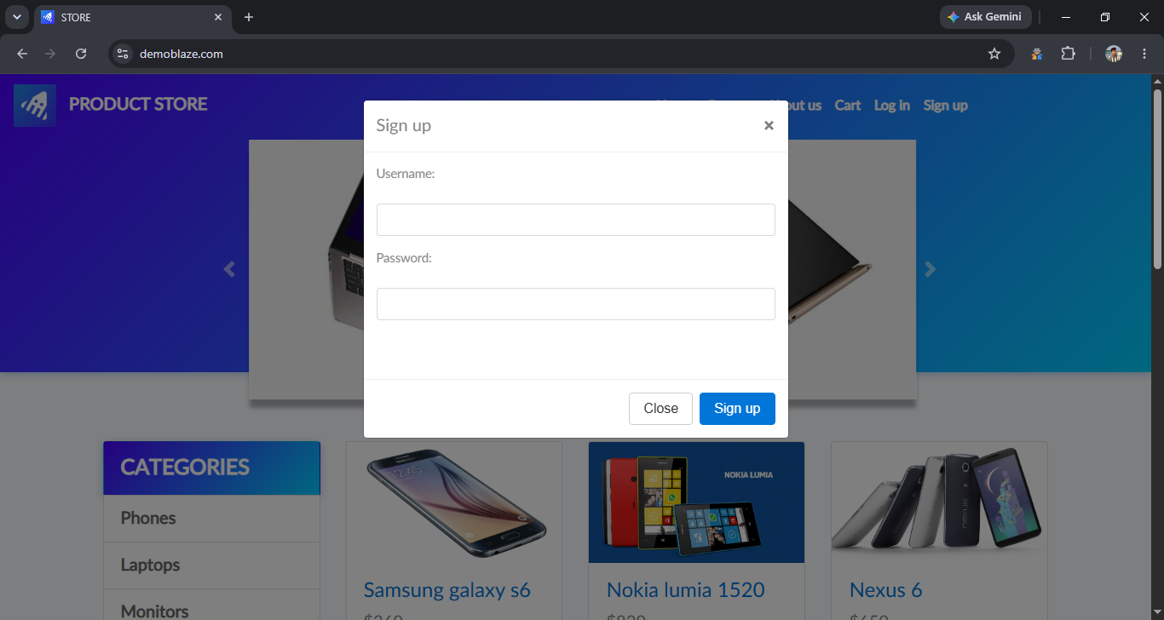

● Scenario ID: 1c
Scenario: Login with Valid Credentials
Test Steps:
Click Log In → Enter credentials → Log in

Screenshots:
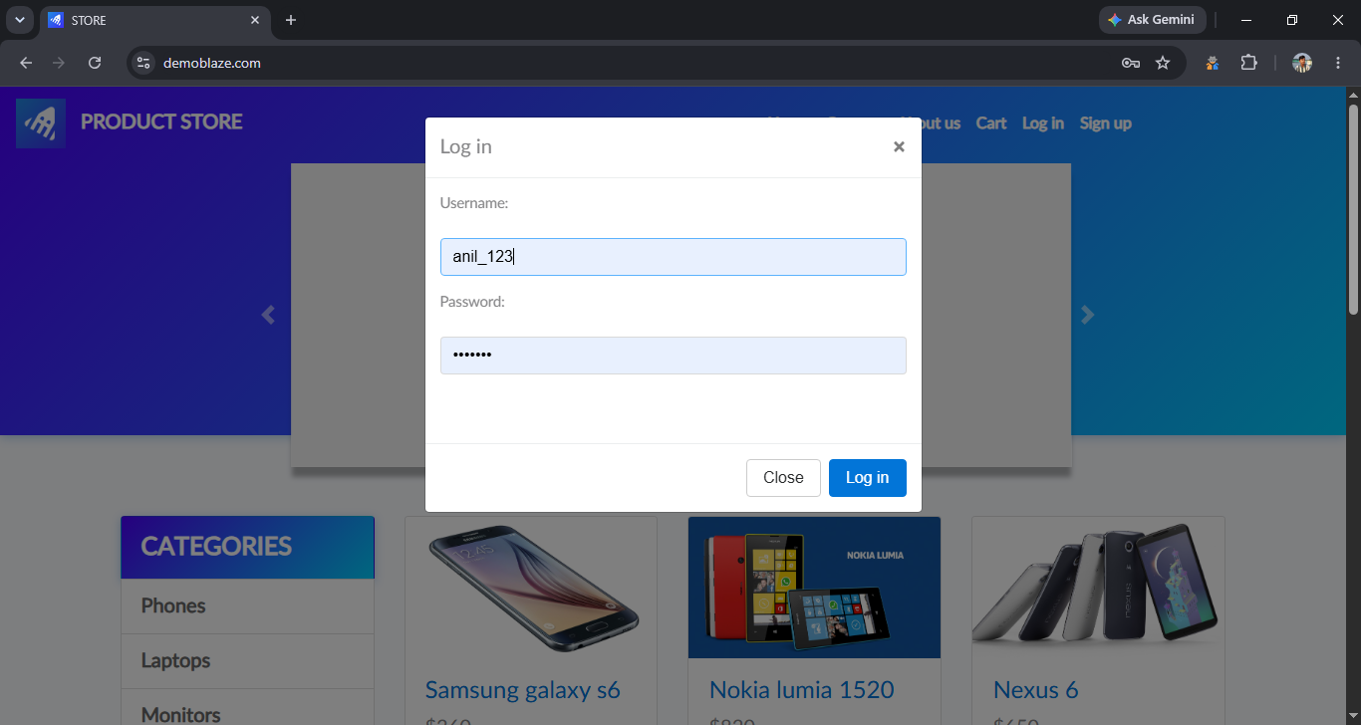

● Scenario ID: 2a
Scenario: Browse Phones
Test Steps:
Click Phones category

Screenshots:
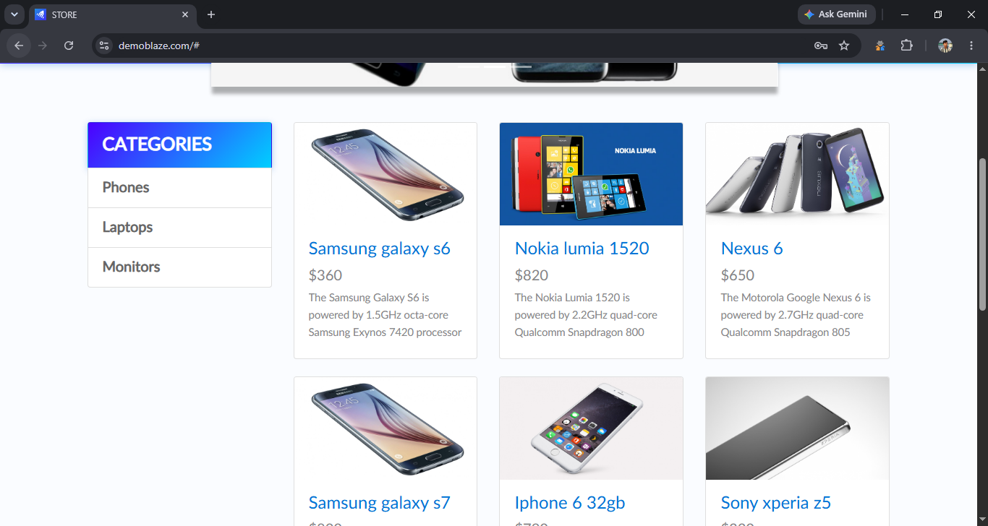

● Scenario ID: 2b
Scenario: Browse Laptops
Test Steps:
Click Laptops category

Screenshots:
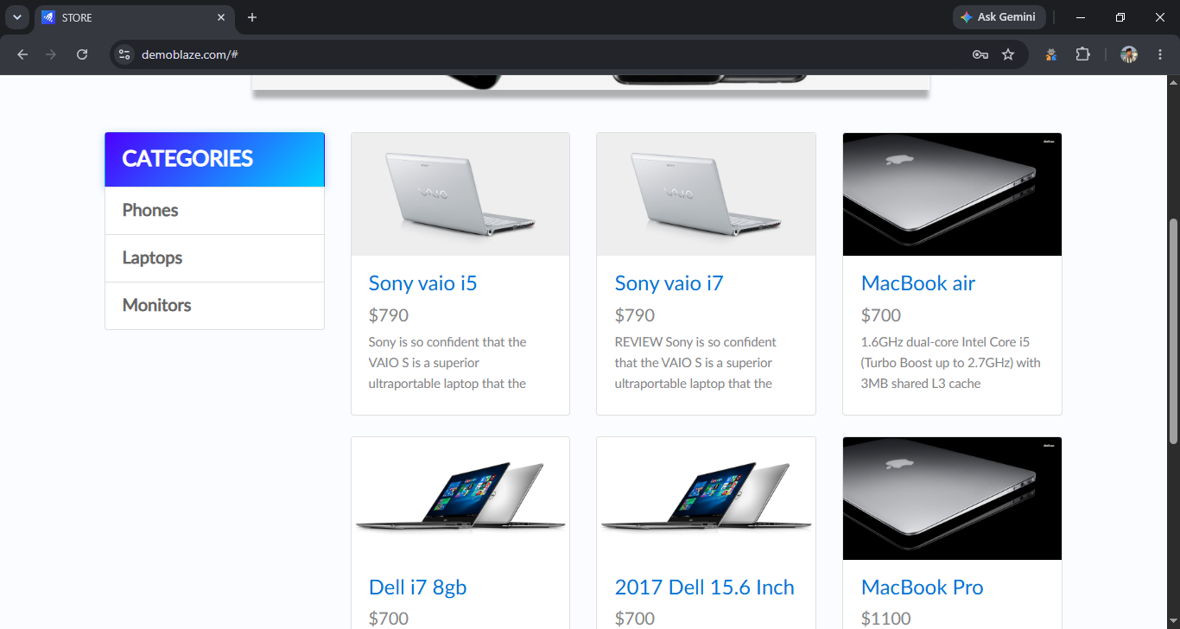

● Scenario ID: 3a
Scenario: Add Product to Cart
Test Steps:
Click Add to Cart

Screenshots:
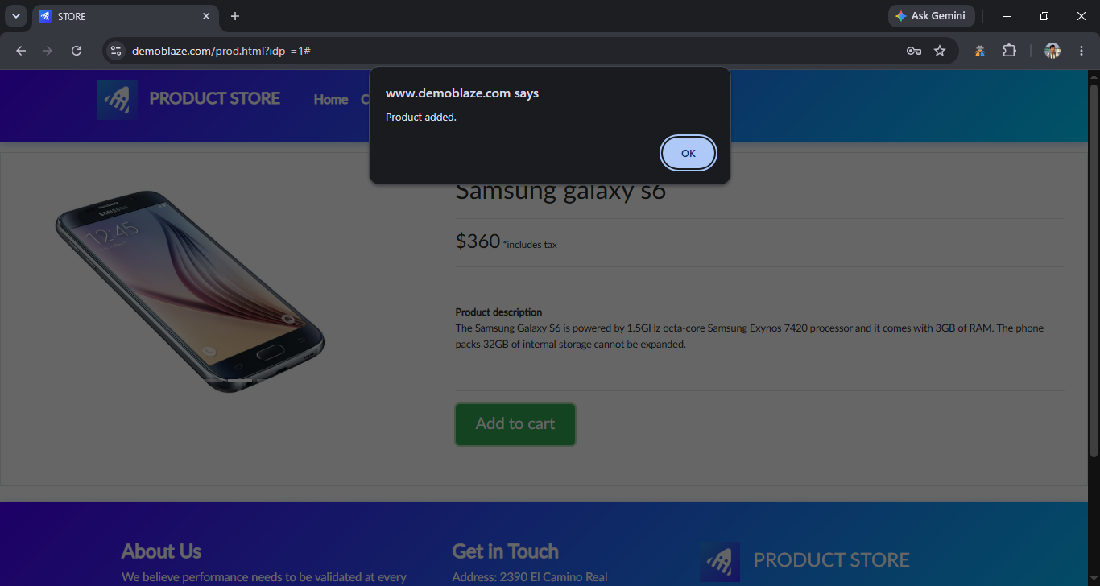

● Scenario ID: 3b
Scenario: Verify Cart
Test Steps:
Open Cart

Screenshots:
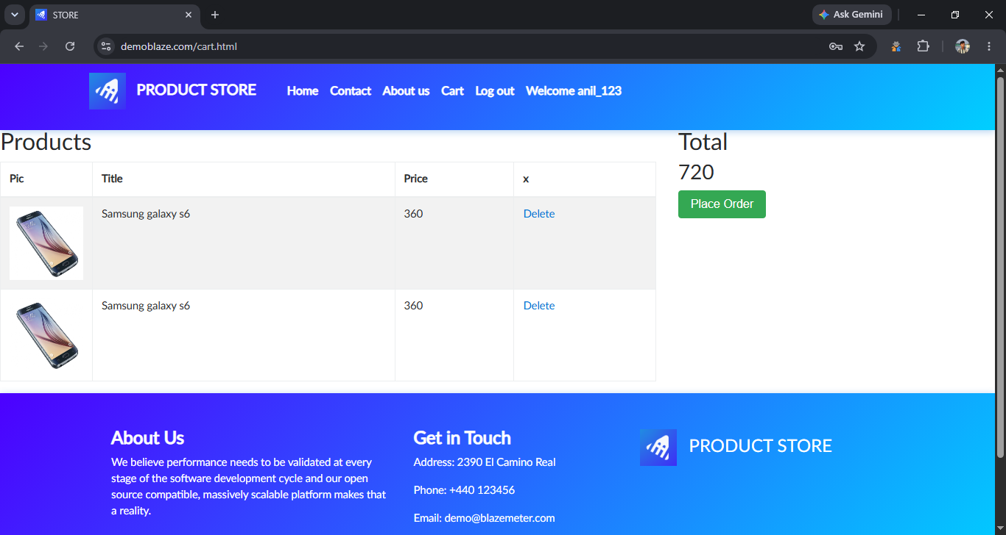

● Scenario ID: 3c
Scenario: Remove Product
Test Steps:
Remove product from cart

Screenshots:
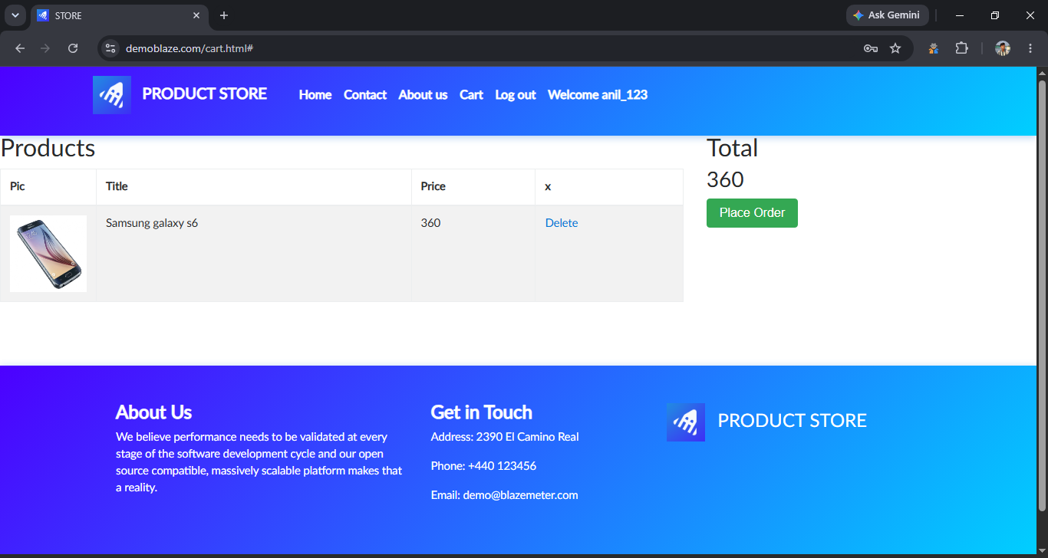

● Scenario ID: 4a
Scenario: Place Order
Test Steps:
Click Place Order

Screenshots:
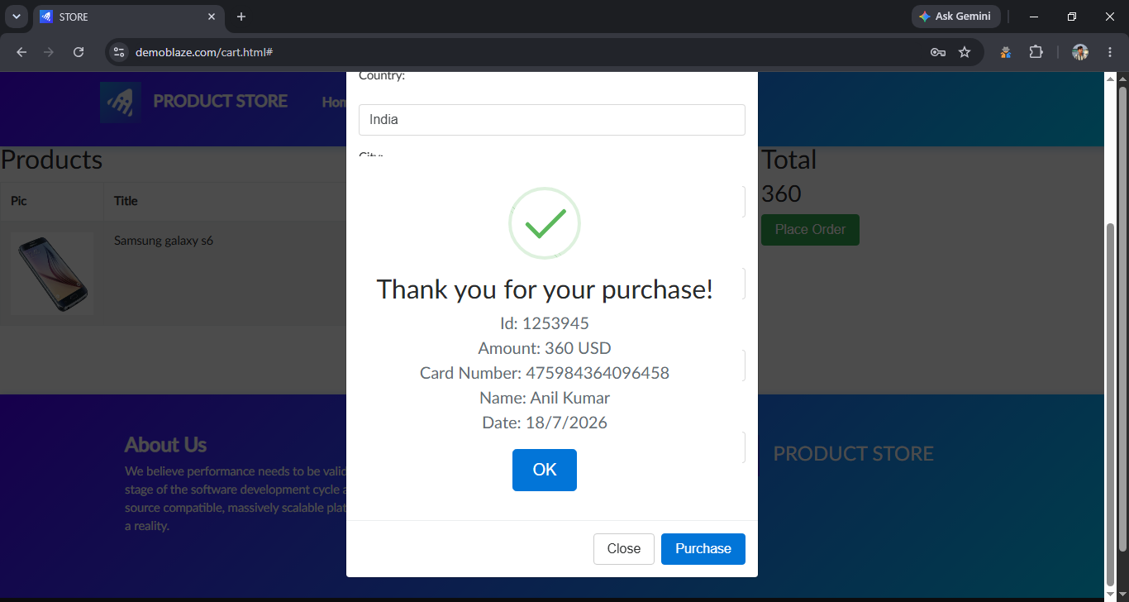

● Scenario ID: 5a
Scenario: Logout
Test Steps:
Click Log Out

Screenshots:


